**SYSTEM’S INSTALLATION MANUAL**

This section gives an overview of the system. It consists of Installation and Configuration Software and Hardware Requirements.

* 1. **System Requirements**

**1.1.1 Hardware requirements**

Server or CPU

Internet Connection

**1.1.2 Software requirements**

Web Browser

Zip file of the system or Install from Github <https://github.com/etherealass/CAPSTOOONE>

Xampp 7.3.2

Composer 1.8.5

Node J.S 10.15.3

Gitbash

* 1. **Installation**
* Download XAMPP 7.3.2 from <https://www.apachefriends.org/download.html>
* Click the downloaded XAMPP file

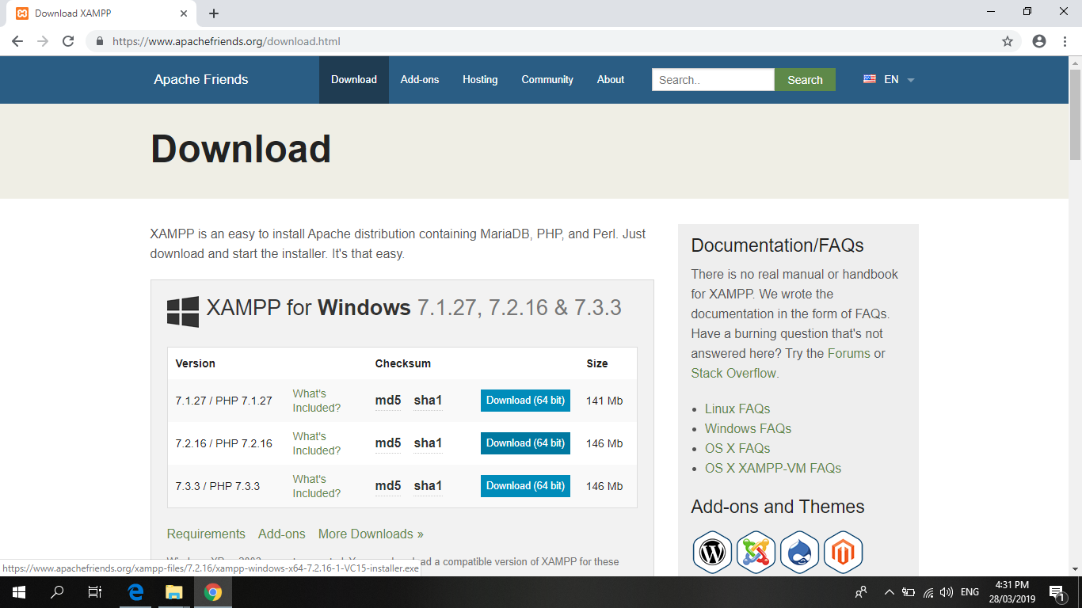

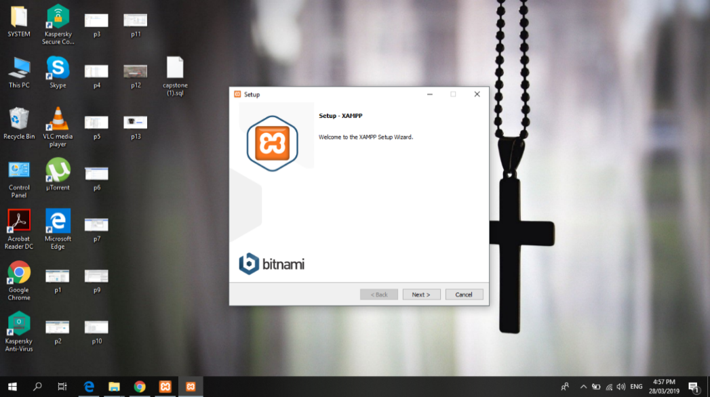

1. Install and run XAMPP 7.3.2
2. 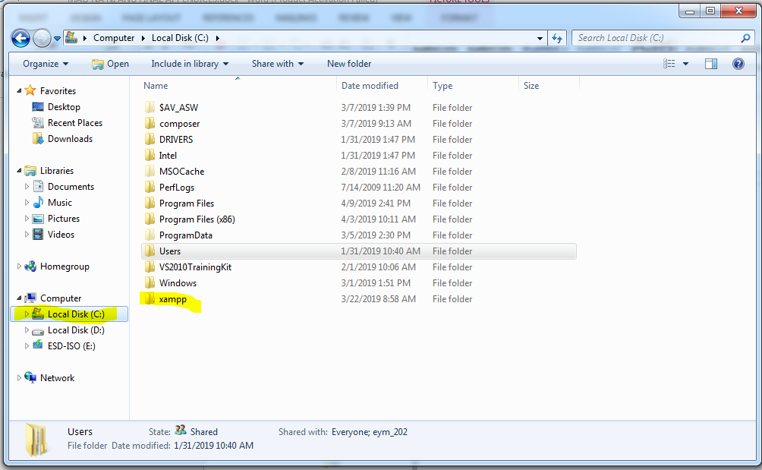Go to C Drive, Click on Xampp
3. Click on htdocs file

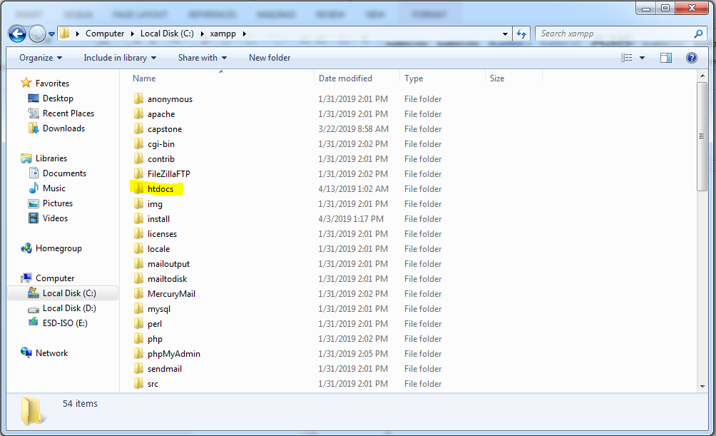

1. In htdocs copy the file, or clone the repository from github.
2. Go to Browser and install GitBash from <https://git-scm.com/download/win>.

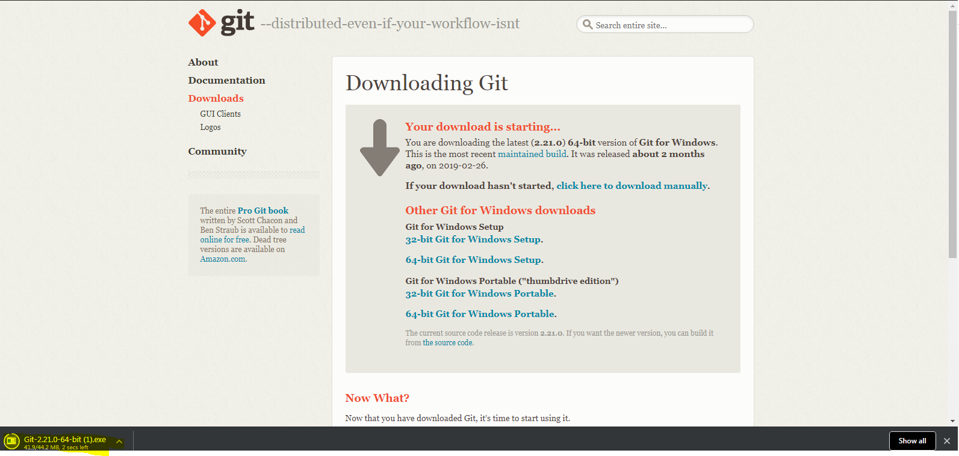

1. Double click highlighted file to start installation.

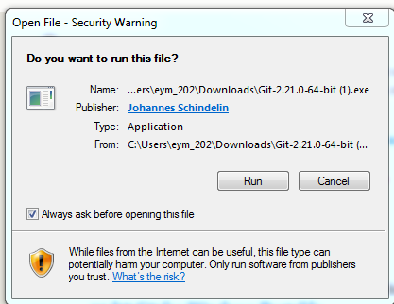

1. Click on Run Button. Click Yes.
2. Read terms and condition then click next until finish.
3. Go back to htdocs folder from C:\xampp\htdocs right click on the file you have clone or have copied.

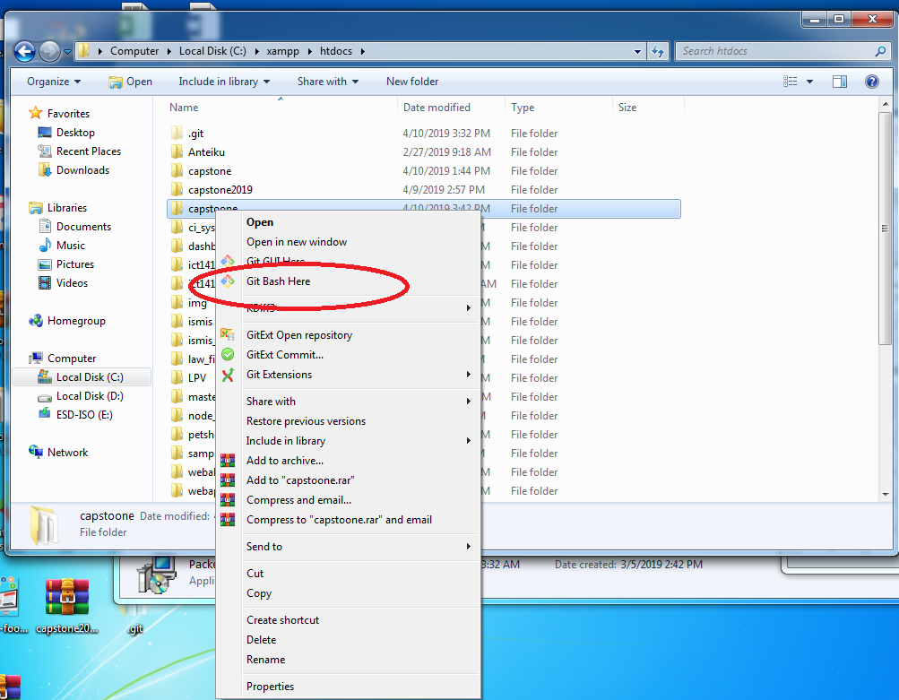

* Clicked on the highlighted menu

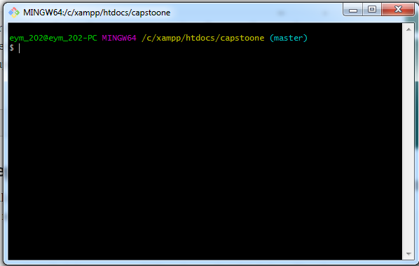

* Write command “composer install” to install composer wait until installation is fully generated.

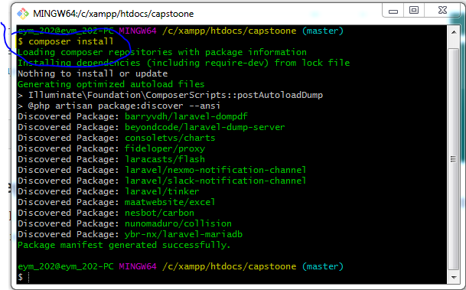

* Write command “npm install” to install node js wait until installation is fully generated
* Go to localhost/phpmyadmin

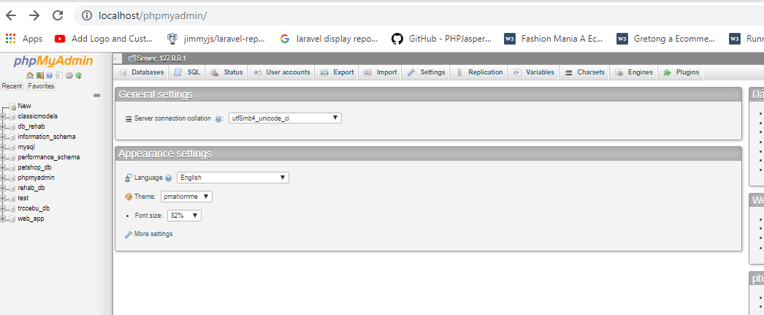

* Create a database in the phpmyadmin where you will store your database
* Open a command prompt

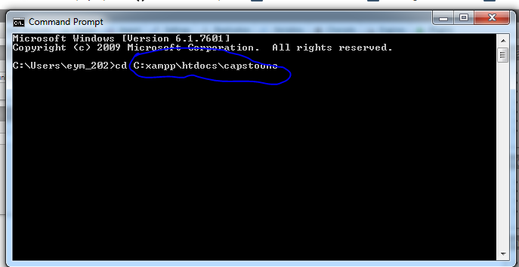

* Go to the folder of your system example command “cd C:\xampp\htdocs\capstoone”
* Copy .env for database using a command prompt “cp .env.example .env”
* Go to the folder of the system look for the .env file open it via sublime, notepad or notepad++.

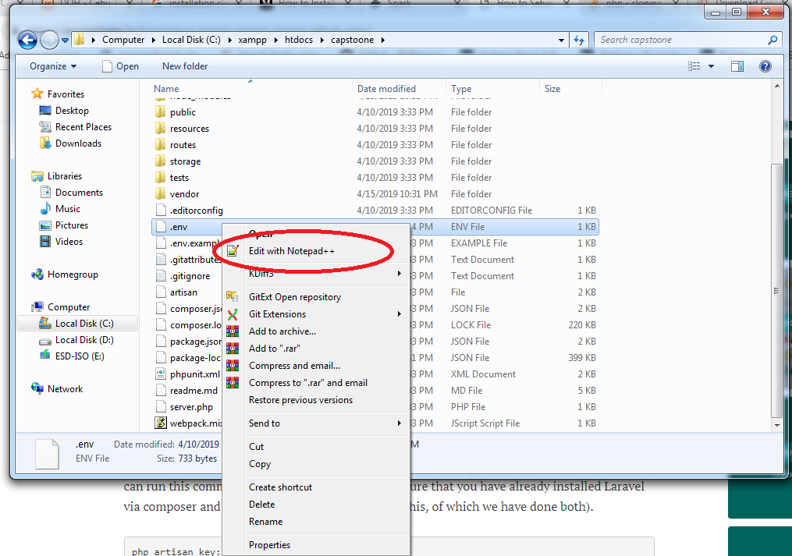

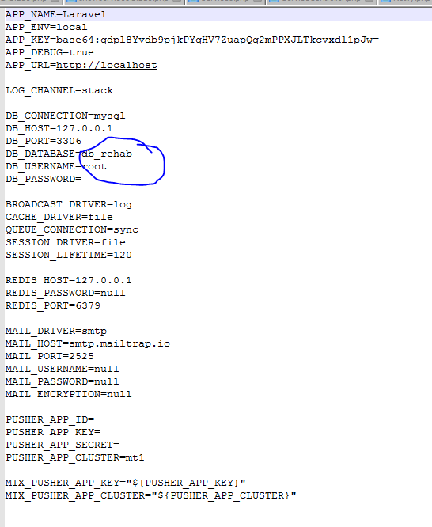

* Edit highlighted in information above to the set up database.
* Go back to command prompt and input command “php artisan key:generate”

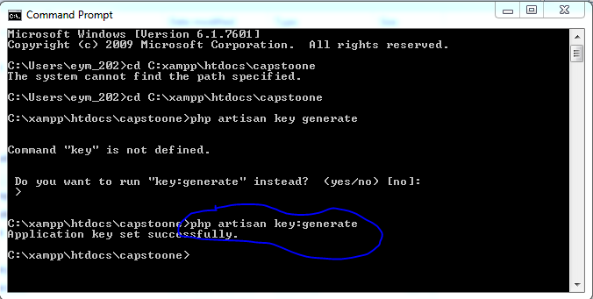

* Input command prompt “php artisan migrate”
* Input command promt “php artisan db:seed”
* Input command prompt “php artisan serve”
* Open another command prompt and input “ipconfig /all”. Look for the ip address of the PC.

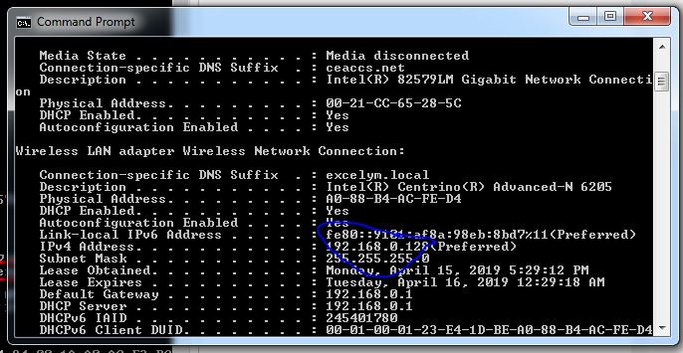

* As what stated system can now be access by another computer via the ip address of the server which is smoothing like the highlighted above.